**CORRELATIONAL ANALYSIS**

**Pearson Correlational Analysis.**

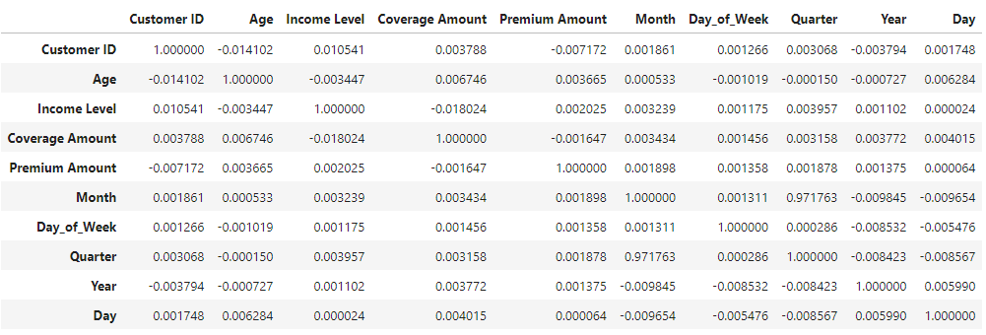

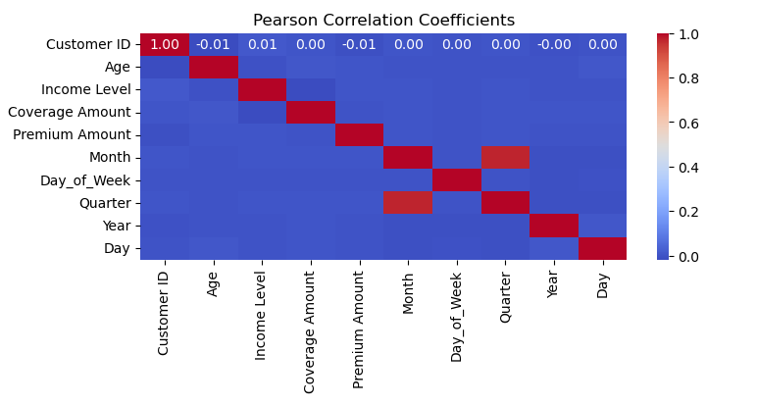

**From the correlation matrix, we can infer several insights:**

Age and Coverage Amount:

There seems to be a weak positive correlation between age and coverage amount (0.006746), suggesting that as age increases, the coverage amount tends to slightly increase.

Income Level and Coverage Amount:

There is a slight negative correlation between income level and coverage amount (-0.018024). This could imply that individuals with higher income levels tend to opt for lower coverage amounts.

Income Level and Age:

The correlation between income level and age is negligible (-0.003447), indicating that there is no strong relationship between income level and age.

Premium Amount and Coverage Amount:

There is no significant correlation between premium amount and coverage amount (0.001647), suggesting that changes in coverage amount do not significantly affect premium amounts.

Age and Day:

There is a weak positive correlation between age and day (0.006284), suggesting that older customers tend to make purchases slightly later in the month.